Abstract Template for DEM10
(Abstract title in Times New Roman, Bold, 14pt)
Author^{1*}, Author², and Author³
¹ Department, Institute, Country
² Department, Institute, Country
³ Department, Institute, Country
*Corresponding author: E-mail address

Abstract
Please prepare a one-page abstract using this template, convert it into a PDF file, and submit it on the DEM10 website. Format: The abstract should contain the title, author names, affiliations, text and references (optional) [1-2], and should be less than one page (A4) with 25 mm margins. The title of your abstract should be written using 14-point Arial. The author names, their affiliations, E-mail, and body text should be used 11-point Times New Roman, respectively. The corresponding author is indicated by * and the presenting author should be highlighted by underline. Figure/Table: You can include a couple of figures and/or tables in the abstract. Color figures and photos are acceptable. Please note the size of the abstract file must be less than 5MB.

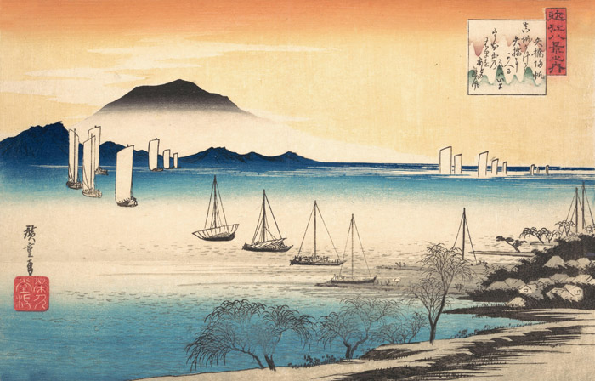
Fig. 1. Caption of Figure/Table. Caption should be 11-point Times New Roman.

References
[1] A. Author and B. Author, Journal Name. 12 (2025) 345.
[2] C. Author, Title of Book, Publisher, Publisher location (2025).

